USER MANUAL
Group 77
Authors:
Raiyan Alam, Denis Gitman, Neel Patkar, Harman Singh, Namit Singh, Arshdip Singh

Contents
1. Login / Registration 2
2. Dashboard 3
3. Search and Filter Courses 3
4. Grade Tracker 4
5. View Course Stats 6
6. Viewing a Leaderboard 6
7. Earning Badges for Completing Courses 9
8. Flashcard maker 12
9. Top 3 Courses 14
10. Goal Tracker 15

1. Login / Registration
Overview: Access the platform by creating an account or logging in.
Steps to Use:
- Click on ‘Login’ if you have an account or ‘Register’ to create one.
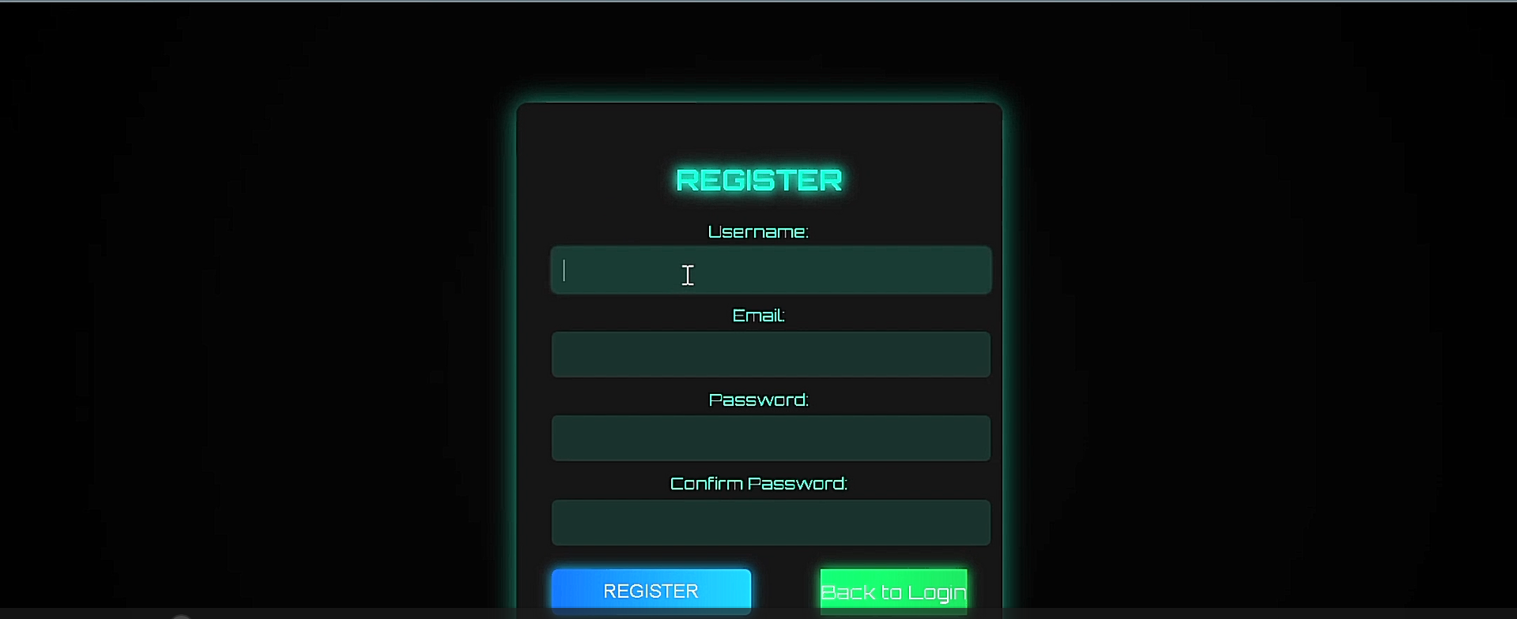
- Enter your email and password.
- Follow the instructions to verify your account.
- After verification, log in to access your dashboard.
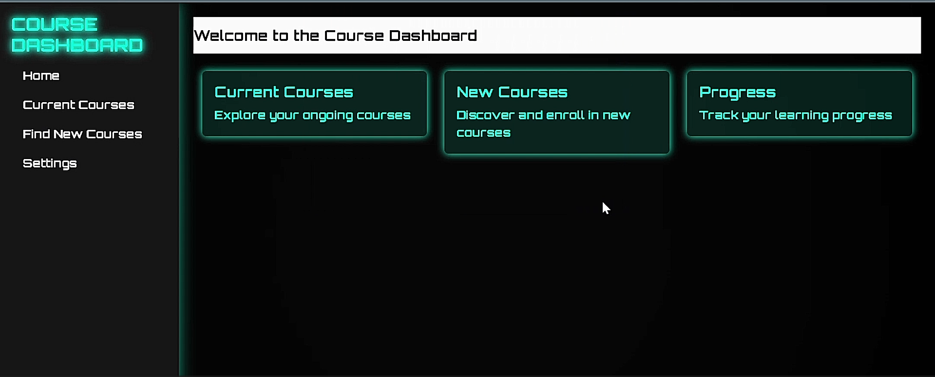

2. Dashboard
Overview: Your central hub for tracking course activity.
Steps to Use:
- Access the dashboard from the main menu.

- View enrolled courses, progress, and notifications.
- Click on any item for more details.

3. Search and Filter Courses
Overview: Quickly find courses based on specific criteria.
Steps to Use:
- User can either search for course name using keywords or categories
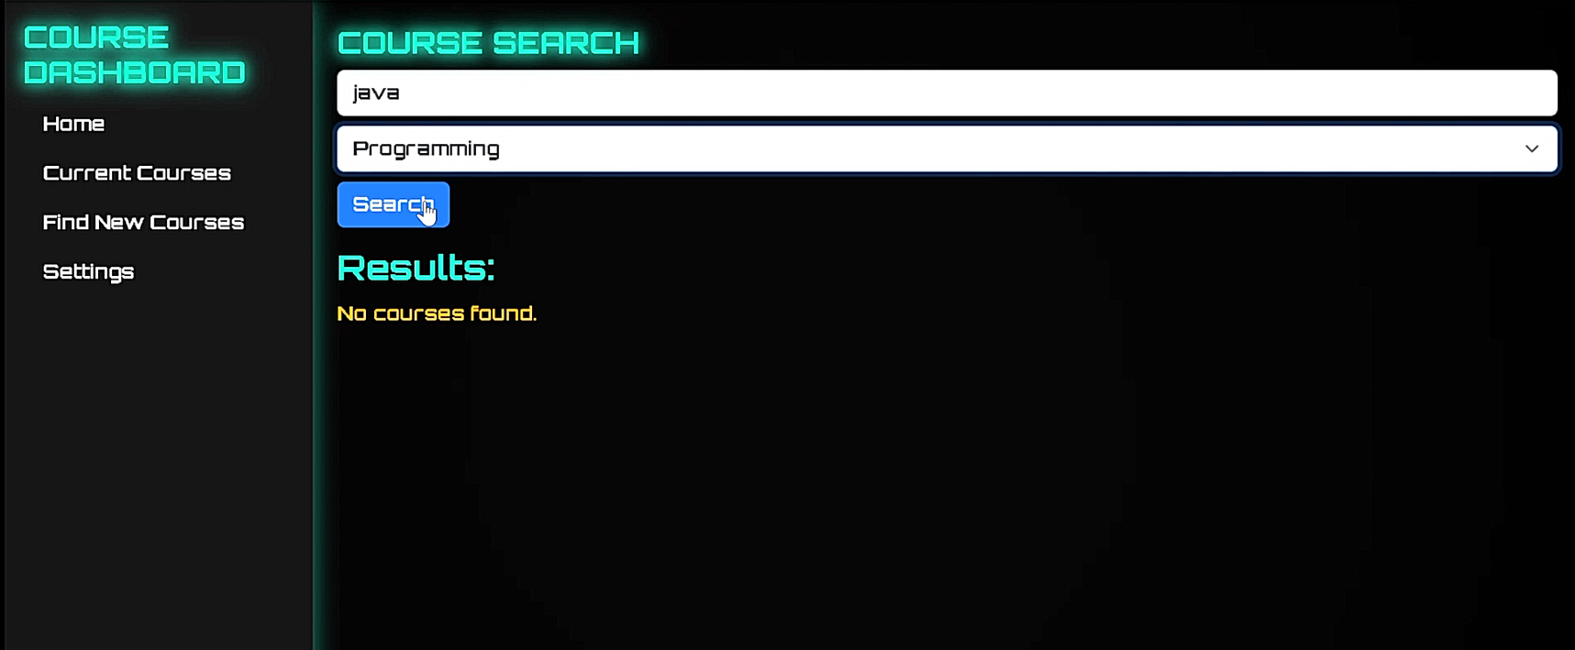
- Click the search button to find the course name
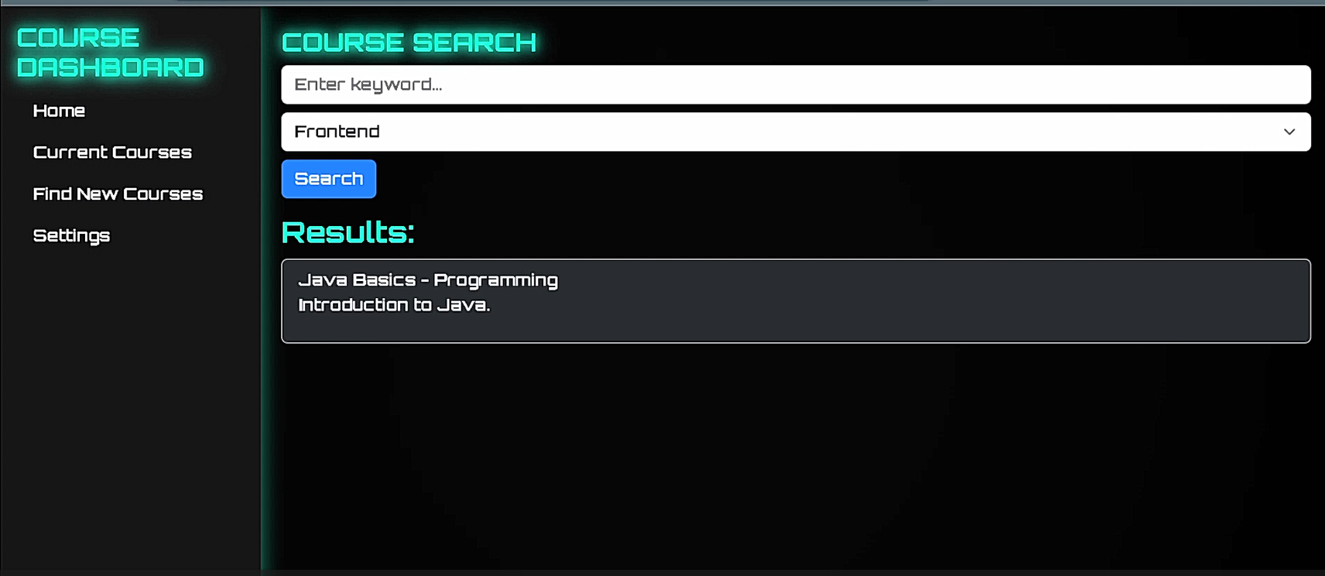
- The results are displayed

4. Grade Tracker
Overview: Monitor your grades and track progress.
Steps to Use:
- User enters course name and weight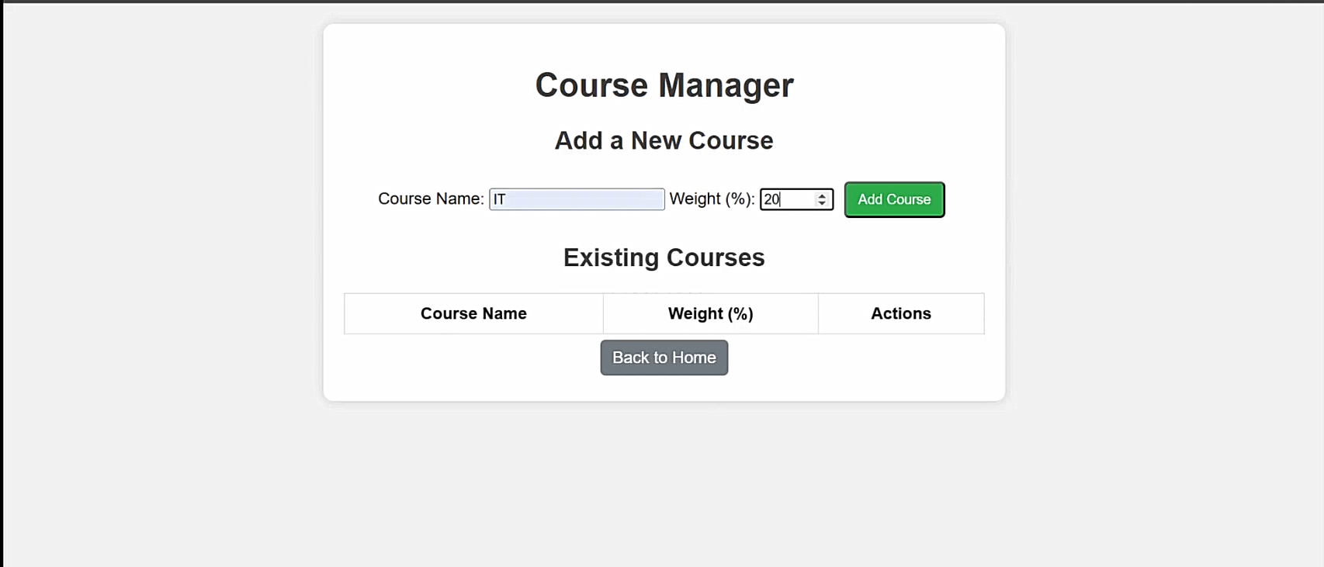
- User clicks the add course button to add the course to the course manager
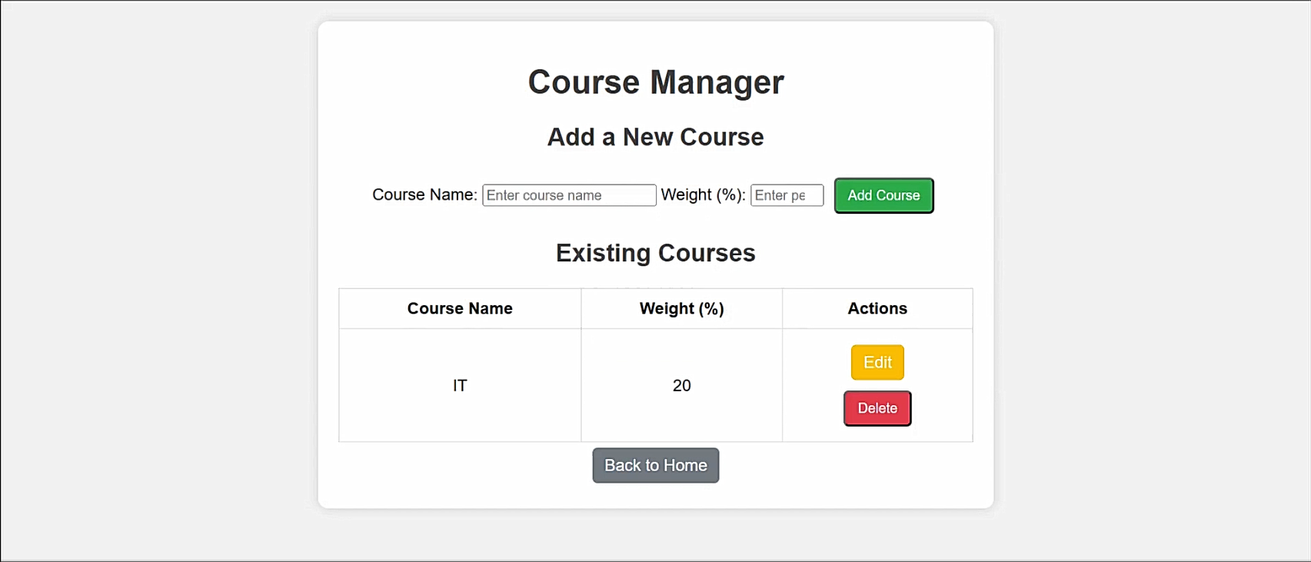
- User clicks on edit course and enters the edit course menu`
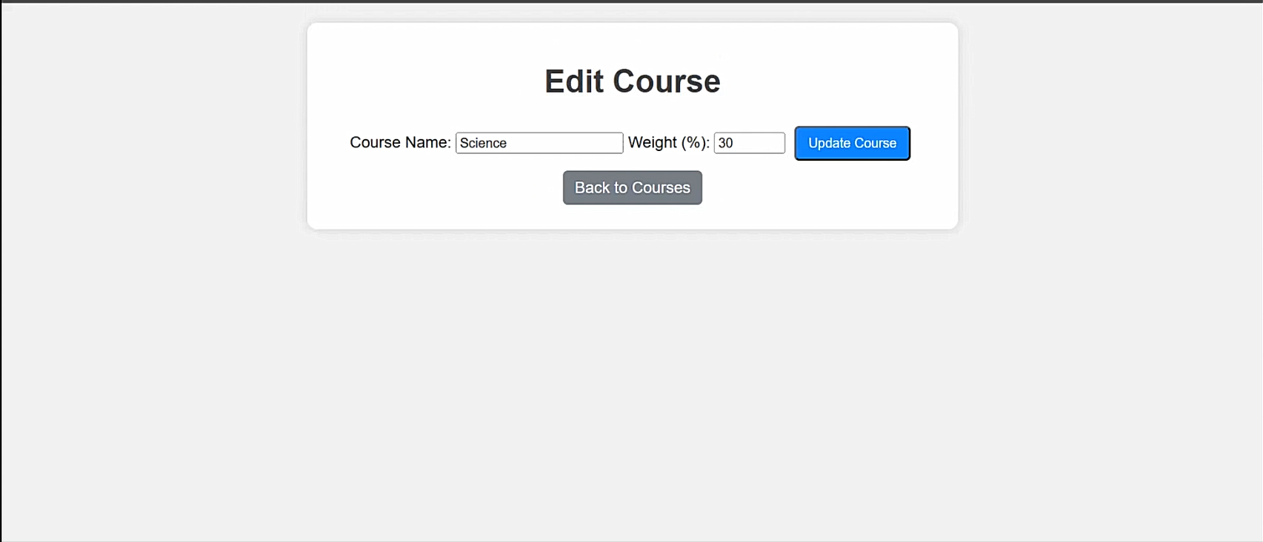

5. View Course Stats
Overview: Analyse course performance metrics.
Steps to Use:
- Go to ‘Course Stats’.
- View completed courses, active courses and total study time.
- Use insights to improve your learning approach.
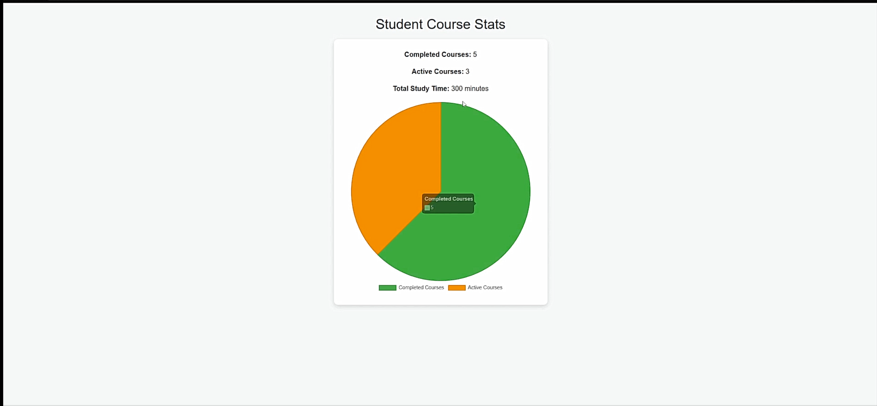

6. Viewing a Leaderboard
Overview
The Student XP Leaderboard is a Java Swing-based desktop application that displays a leaderboard of students ranked by their Experience Points (XP). The data is fetched from a MySQL database and presented in a user-friendly graphical interface. The application supports pagination, refreshing, and viewing detailed information about each student.

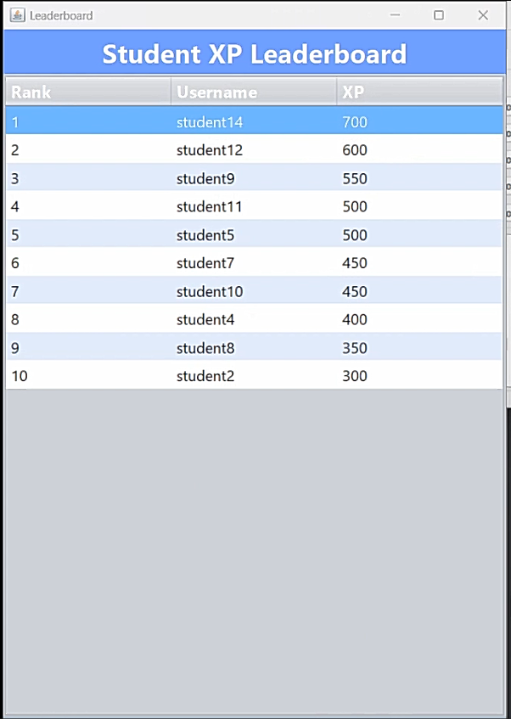
Key Features
Dynamic Leaderboard Display :
  - Displays students' rankings, usernames, and XP scores in a table.
  - Data is fetched dynamically from a MySQL database.
Pagination :
  - Supports navigation between pages using "Previous" and "Next" buttons.
  - Each page shows up to 10 students (configurable).
Refresh Button :
  - Reloads the latest data from the database to reflect any updates.
Row Details :
  - Clicking on a row in the table displays a popup with the selected student's username and XP.
Styling :
  - Alternating row colours for better readability.

The application has three main sections:
Header Panel
Displays the title: "Student XP Leaderboard" .
Provides a clean and professional look with a blue background.
Table
Shows the leaderboard with the following columns:
Rank : The student's position based on XP.
Username : The name of the student.
XP : The student's experience points.
Rows are styled with alternating colours (light blue and white) for readability.
Buttons
Located at the bottom of the window:
Previous : Navigate to the previous page of students.
Next : Navigate to the next page of students.
Refresh : Reload the data from the database to reflect any changes.

View Student Details :
Click on any row in the table to see a popup with the selected student's username and XP.
Navigate Pages :
Use the Previous and Next buttons to move between pages if there are more than 10 students.
Refresh Data :
If new students are added to the database or XP values are updated, click the Refresh button to reload the latest data.

7. Earning Badges for Completing Courses
Overview: Earn achievement badges when you complete a course.
Steps to Use:
- User enters the course ID they have completed
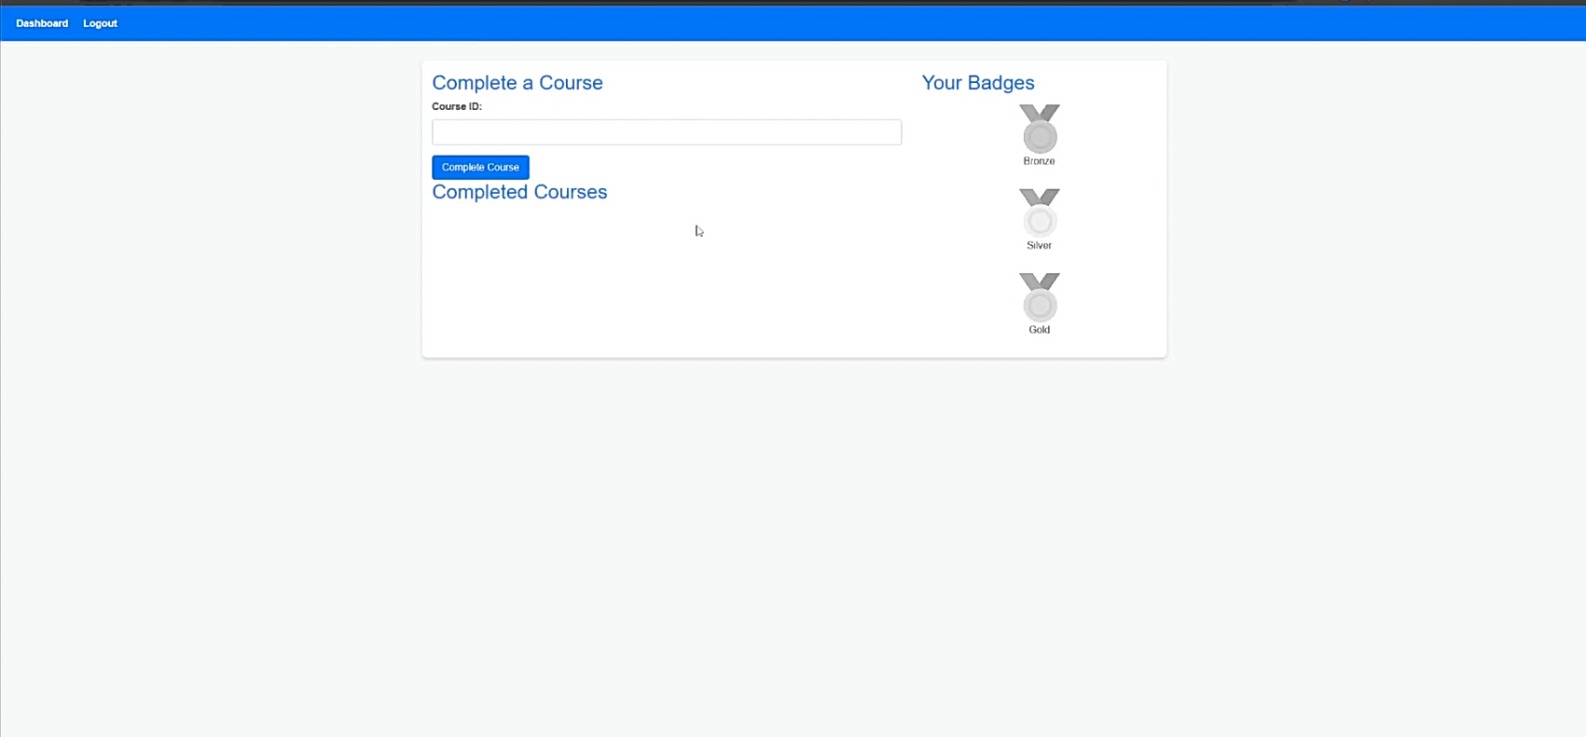
- User clicks on complete course
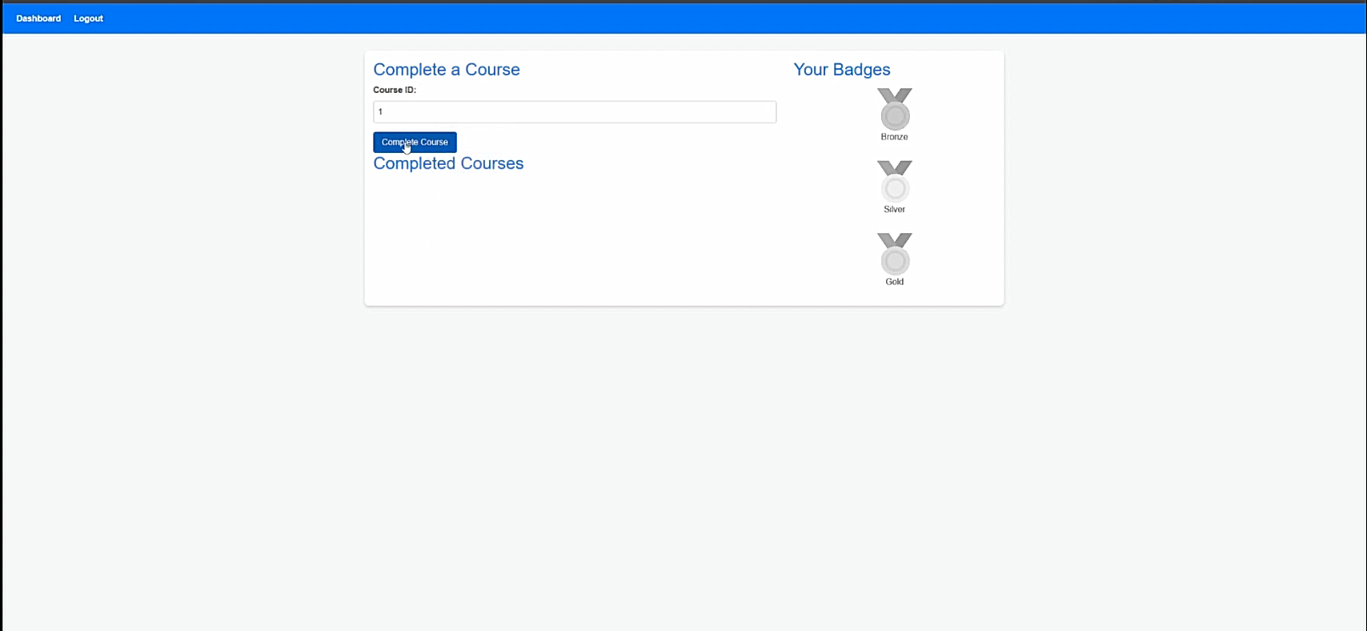
- Course is marked as completed
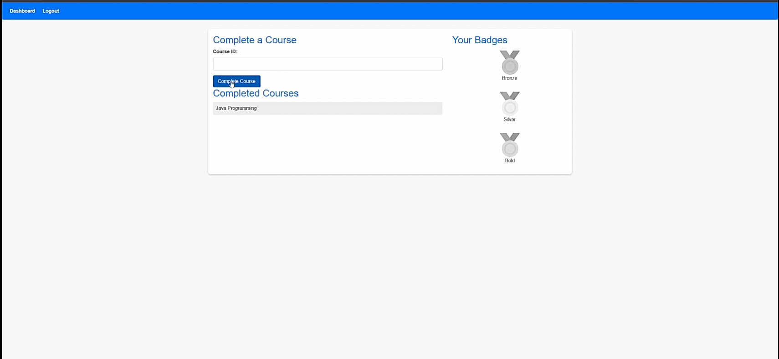
- After 5 courses have been marked as completed, the bronze badge will be awarded
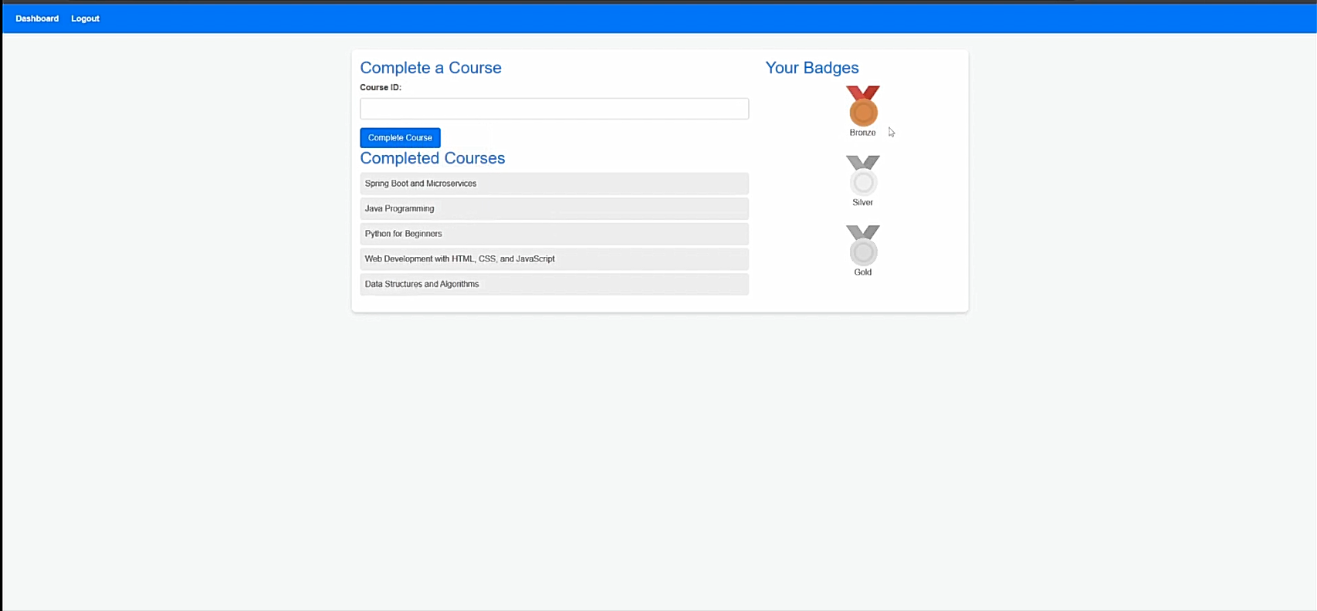
- After 10 courses have been marked as completed, the silver badge will be awarded
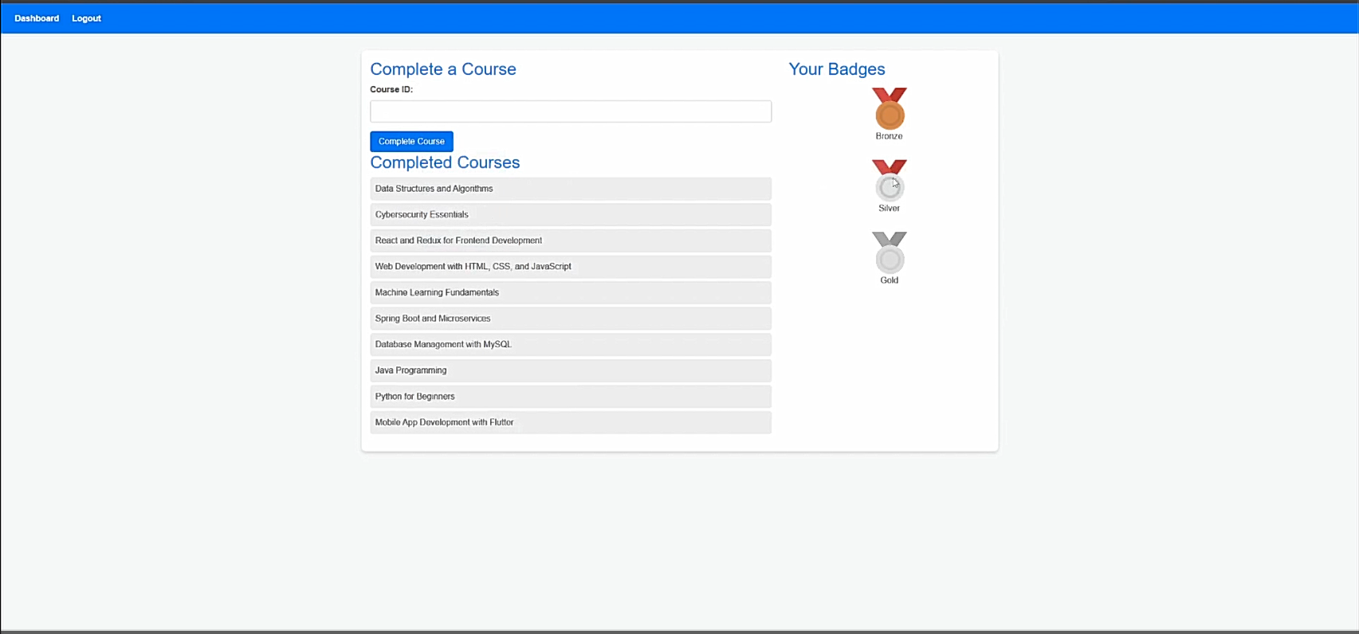
- After 20 courses have been marked as completed, the gold badge will be awarded
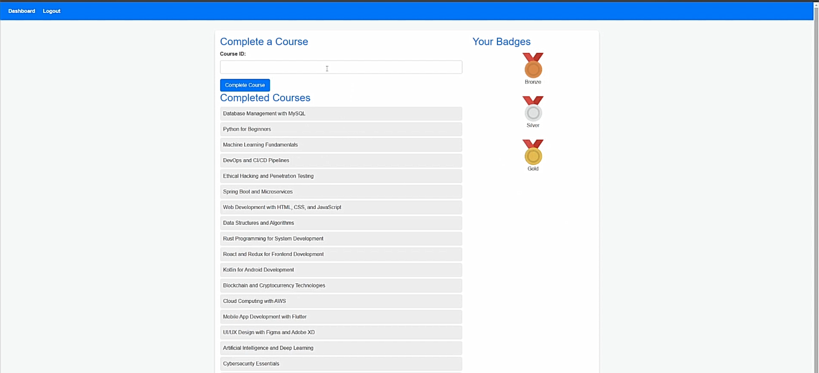

8. Flashcard maker
Overview: Create flashcards and test users’ knowledge
This feature of the application will allow users to create their own flashcards to help them revises for their courses and test their knowledge. When the program is first loaded the main menu will load up so that the user can create their flashcard or play the game.
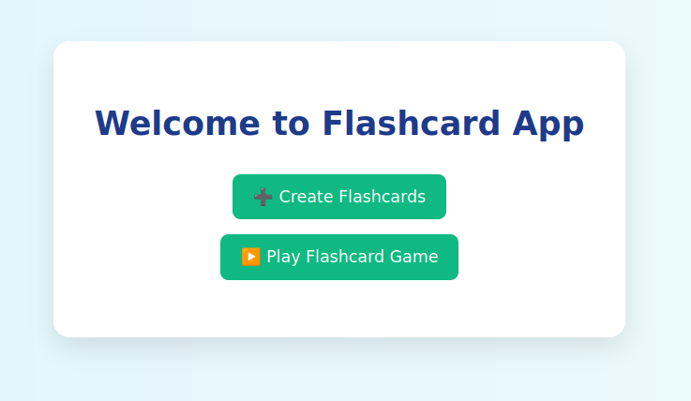

This program works by first having the user to create their flashcards with the help of validations and other features of the program such as the remove button if they don’t want the flashcard anymore. This ensures that no issues arise in the next phase and that the flashcards are accurately correct to what the user wants.

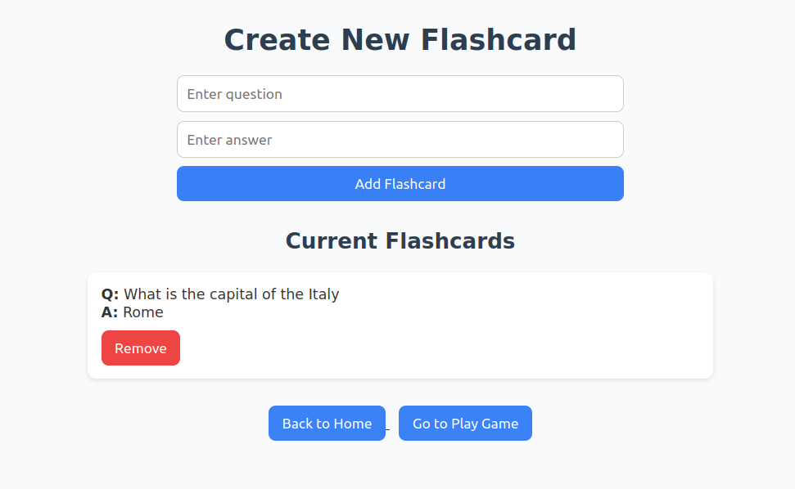

After the user is happy with their flashcards they can participate in the game mode to test their knowledge in a timely manner if they would like to. The user will be first asked to select how long they would want their timer to be on for with a range of options from 2mins, 5mins, 10mins of unlimited time.
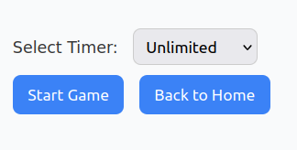

After the user has their option from above, the game will begin after they click on “start game” and the timer will start if they have selected any. The users will be asked questions from the flashcards they have created and will have to answer them. The user’s input will be checked if its correct in which case a correct message will appear, but if the input is wrong then an incorrect message will appear alongside the right answer. A score streak will also be displayed if the user gets three answers correct in a row which will end if their steak ends due to an incorrect answer.
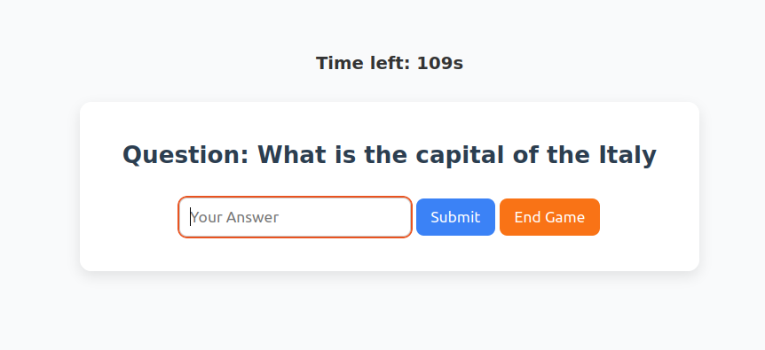

After the last question had been answered the users results will appear to show how they have performed, with data such as what percentage they received so they can reflect on their attempt. A summary will be shown and the user can decide if to play again or go back to the main menu.
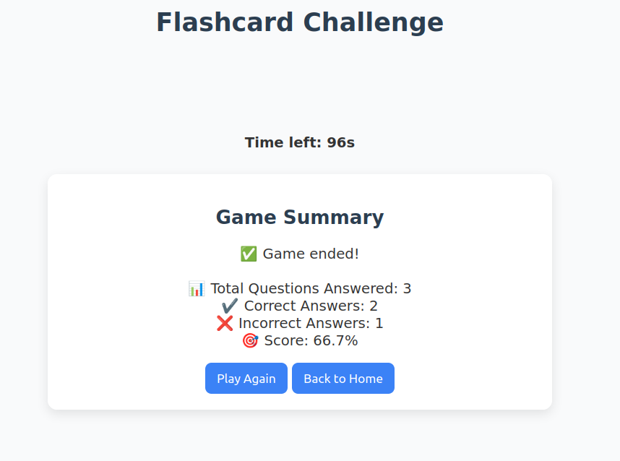

This program has been made user friendly with the help of validations and easily understandable navigation tools. It is also keyboard friendly, meaning the user can easily enter their answers from the enter button on their keyboard for example and case sensitive.

9. Top 3 Courses
Overview: Shows the user the top 3 most popular courses
Steps to Use:
1. User goes onto either the dashboard or the course stats page
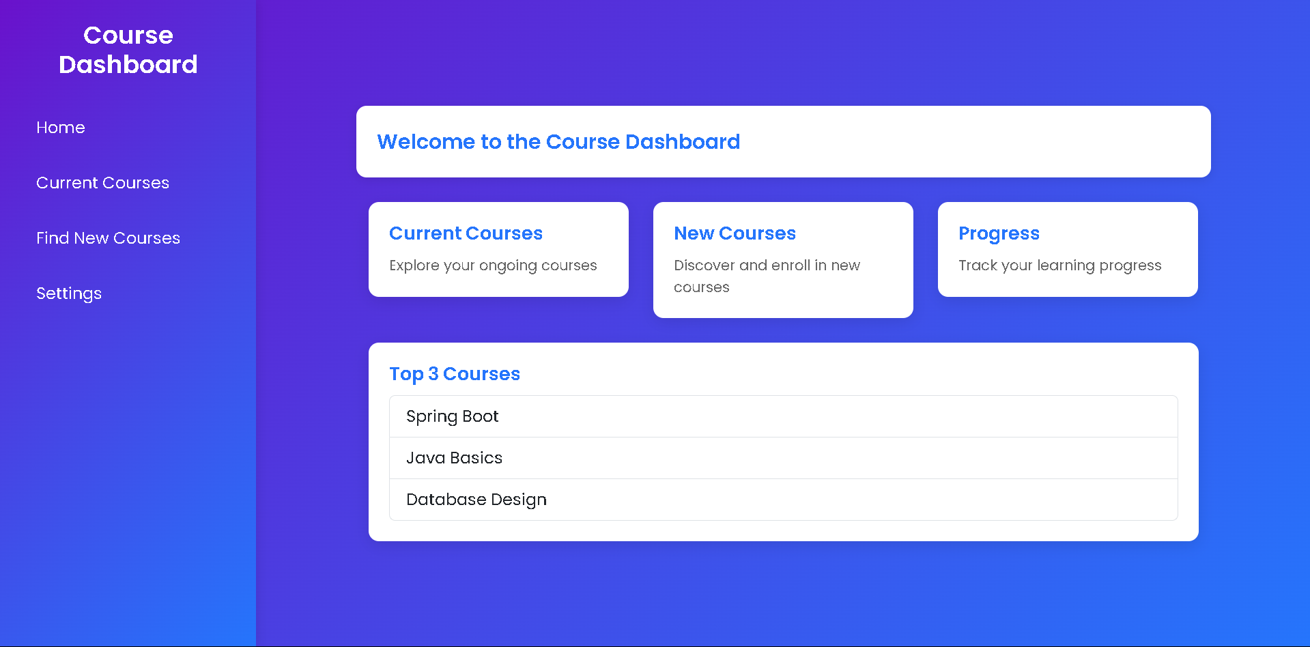
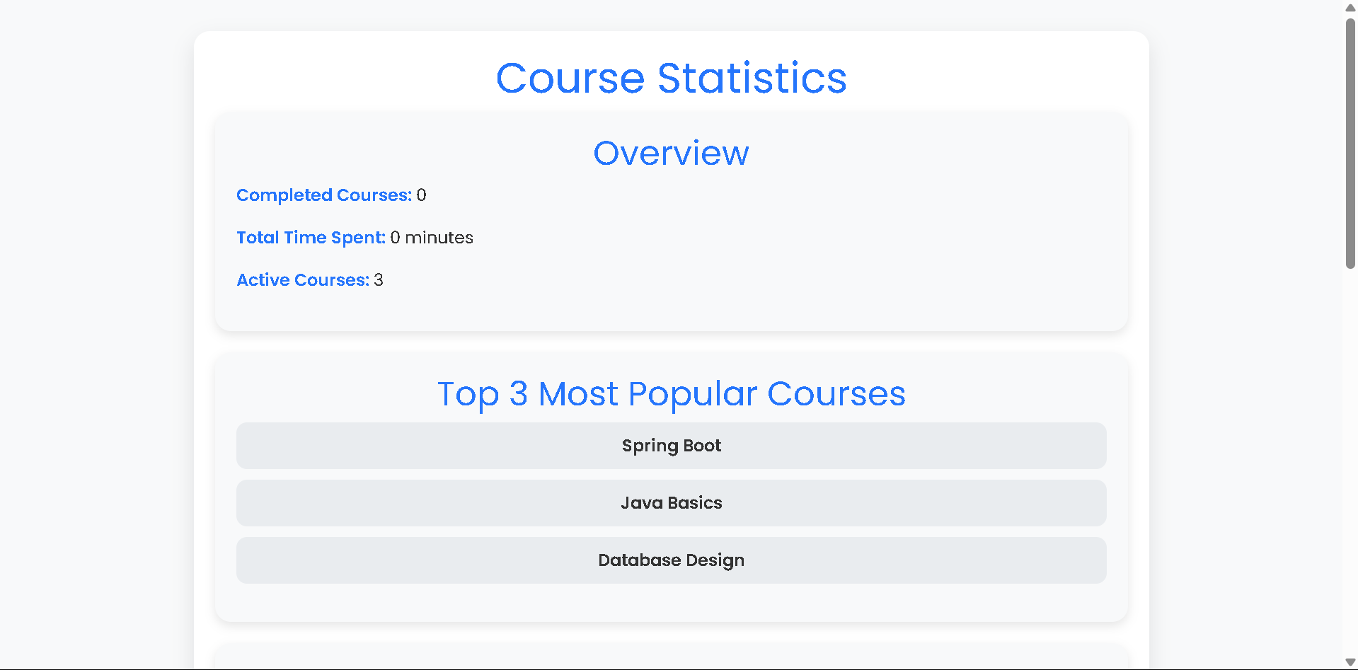

- Then once on that page, the user will see the top 3 courses section on the page and be able to view it.
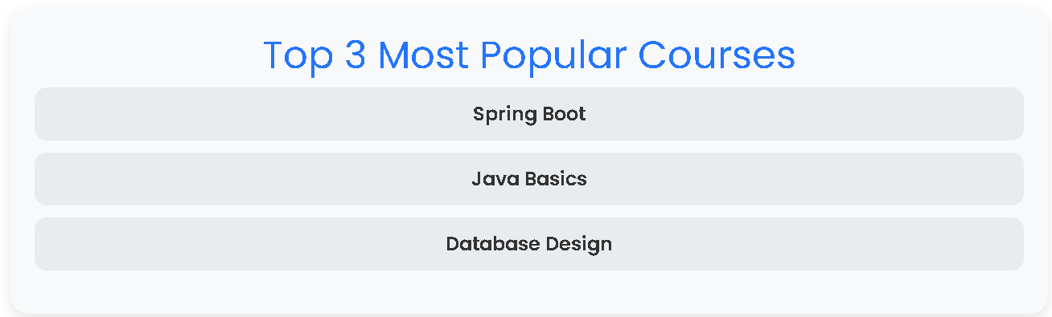

10. Goal Tracker
Overview: Allows the user to set, edit, and delete personalised goals
Steps to Use:
- Accessing the Goals Tracker:
  - Once the user logs into their account and clicks on the goal tracker button in the sidebar on the dashboard they will enter the Goals Tracker page.
  - The Goals Tracker displays a list of each of the three states that a goal can inhabit.
    - Active Goals: the goal has been set and is currently in progress
    - Expired Goals: Goals that remain incomplete and have passed their expiration date
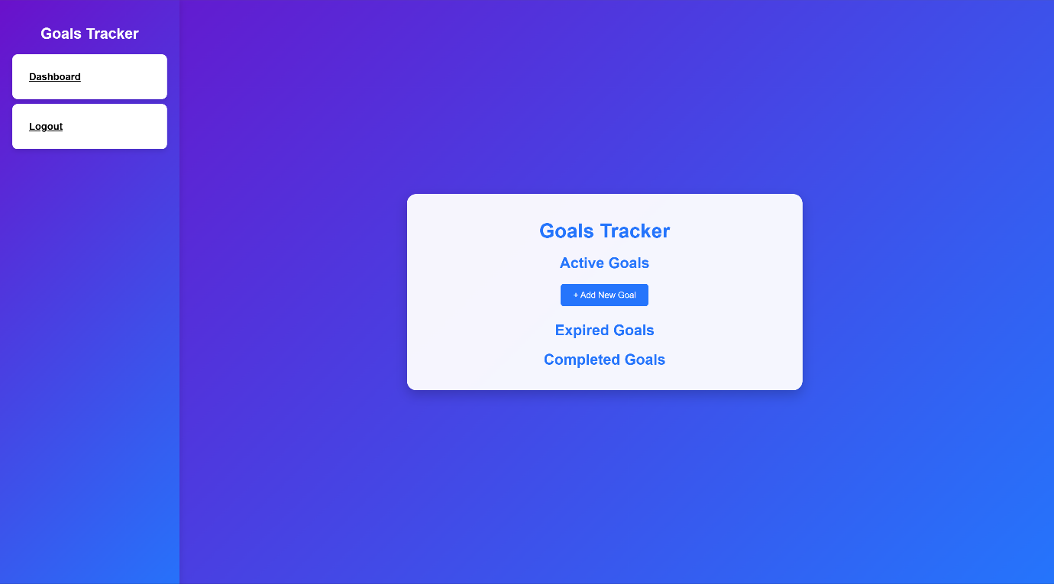
    - Completed Goals: Active goals that the user has marked as complete
  - If the user has already created goals the Goals Tracker will fetch their goals and display them.
    - Each goal contains a goal title, the expiration/completion date, an Edit button, a Complete button and Delete button.
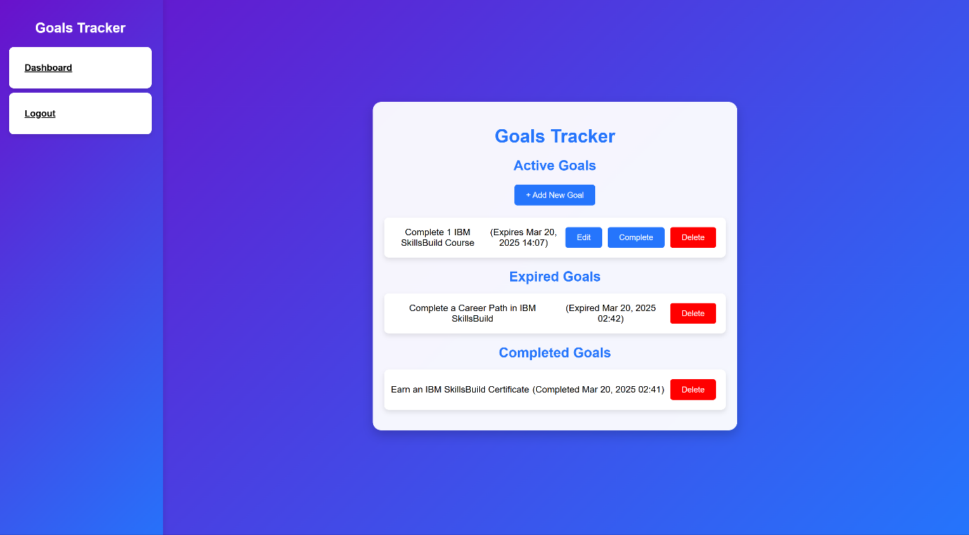
- Adding a Goal:
  - The user clicks the “+ Add New Goal” button in the Active Goals section.
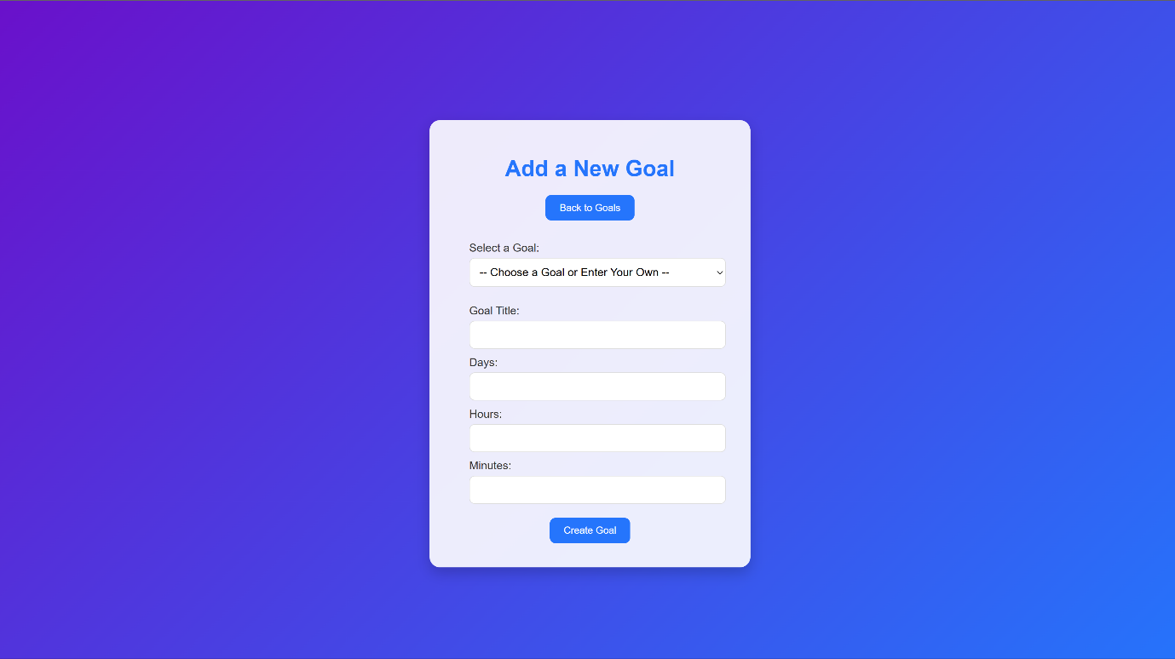
  - The user will then be redirected to the Add Goal page.
  - The user will then be able to create their own personalised goal by writing the goal into the Goal Title input field or choosing a goal title from the dropdown list of pre-defined goals.
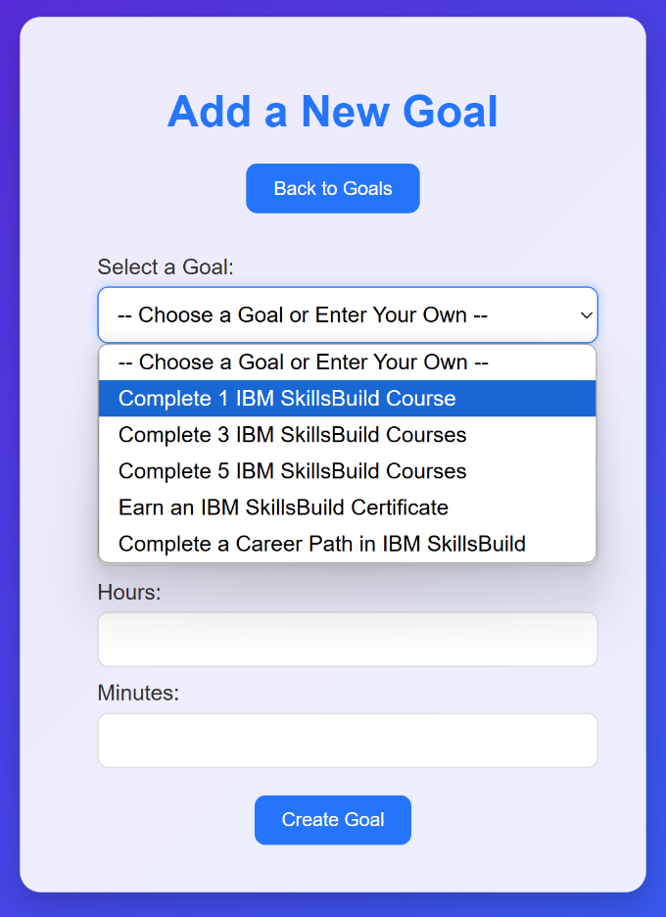
  - The user can then select the duration for the goal by selecting the exact number of days, hours and minutes they want the goal to remain active for.
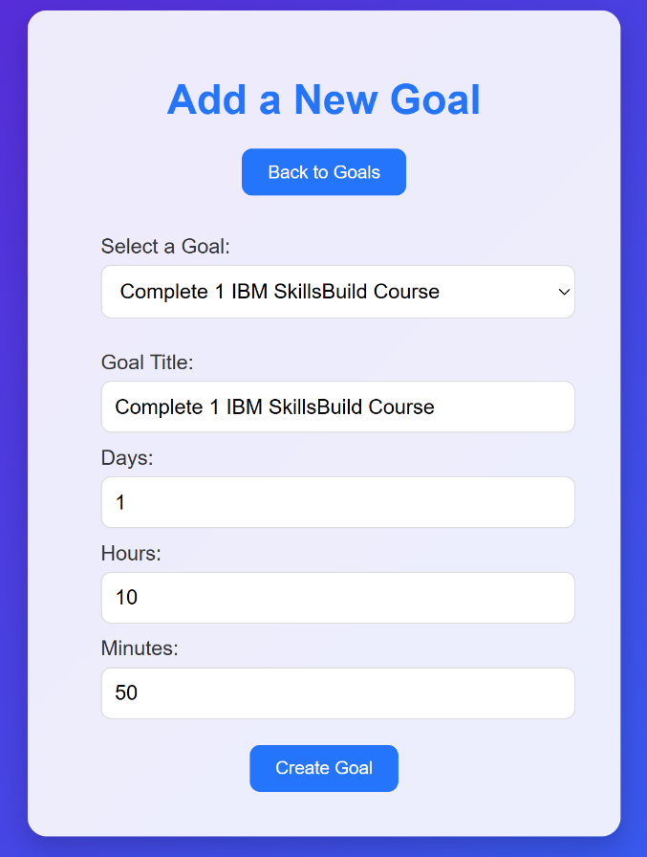
  - The user can then click the “Create Goal” button to redirect the user back to the goals page with the new goal now displayed in the Active Goals list.

- Editing a Goal:
  - On the Goal Tracker page, the user can choose to edit a goal by clicking the “Edit Goal” button next to the specific goal that they want to edit.
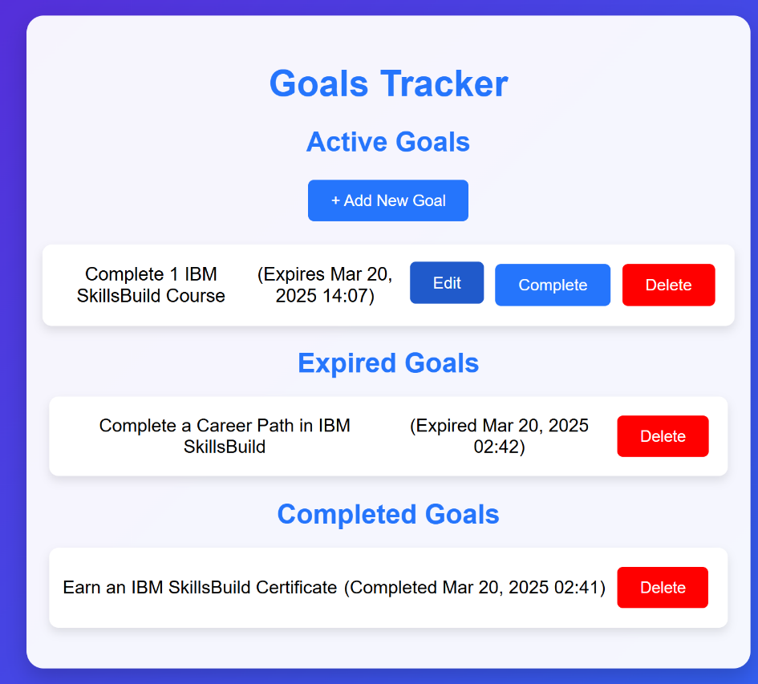
  - The user will then be redirected to the Edit Goals page.
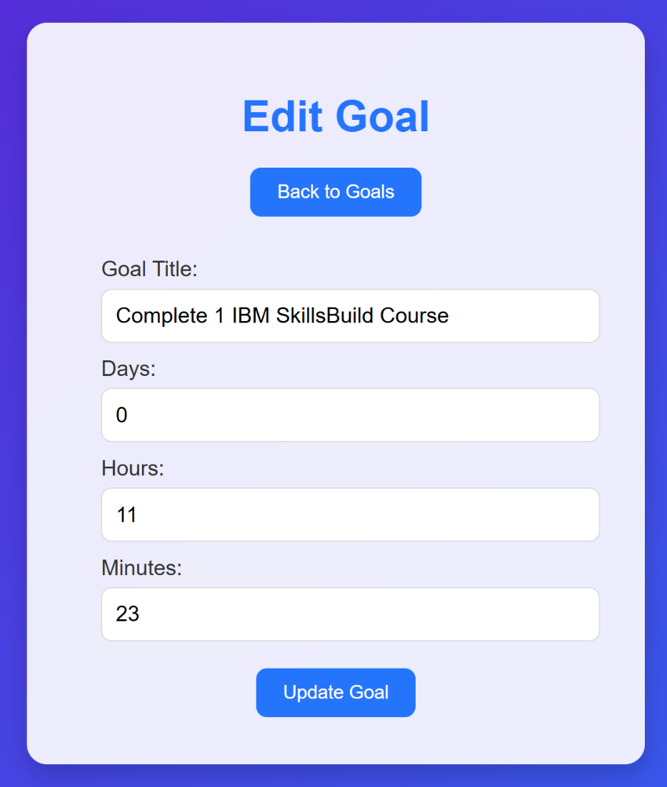
  - The user can now select which specific element of the goal they want to change (either the goal title or the goal duration).
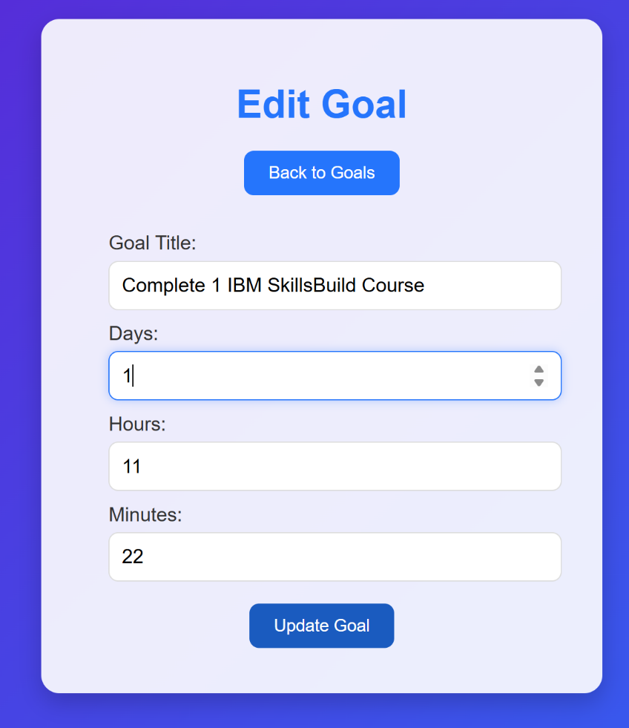
  - The user can then click on the “Update Goal” button to save the changes to the goal and redirect back to the Goal Tracker page with the edited details of the goal inside the Active Goals list.
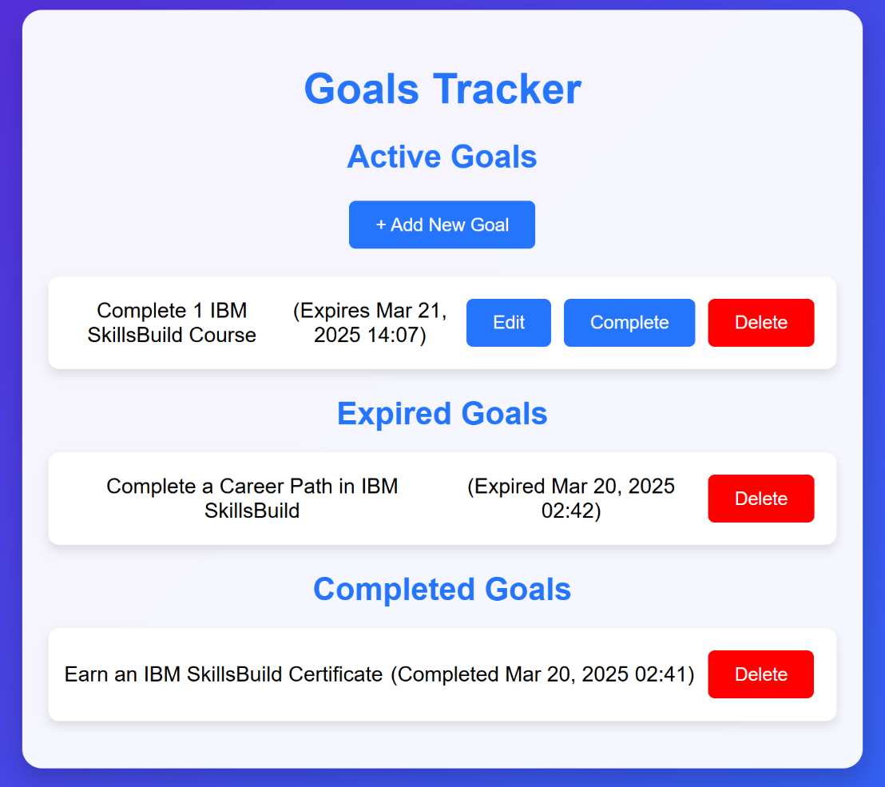
- Completing a Goal:
  - Inside the Active Goals list the user can select a goal that they want to complete.
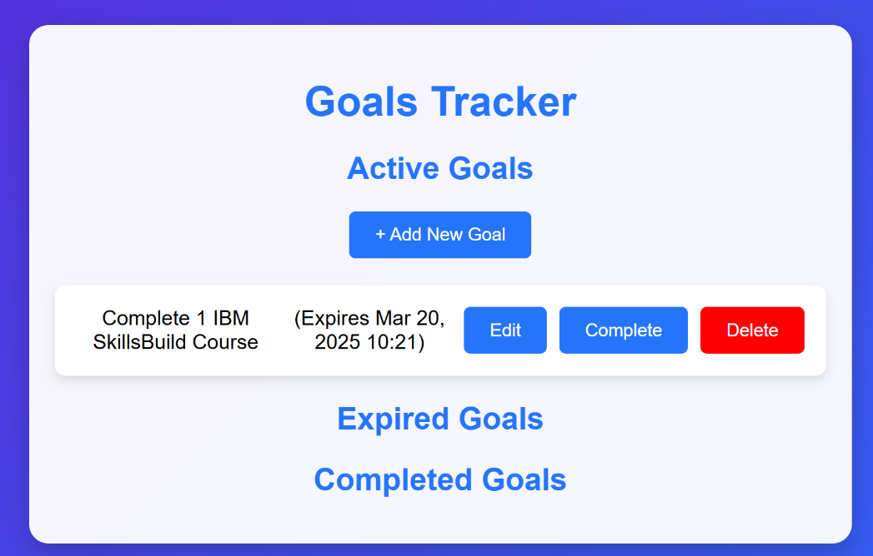
  - The user can then click on the “Complete” button next to the goal that they want to complete.
  - Now that the goal has been marked as completed it will then be moved into the Completed Goals list where it will now display its completion date.
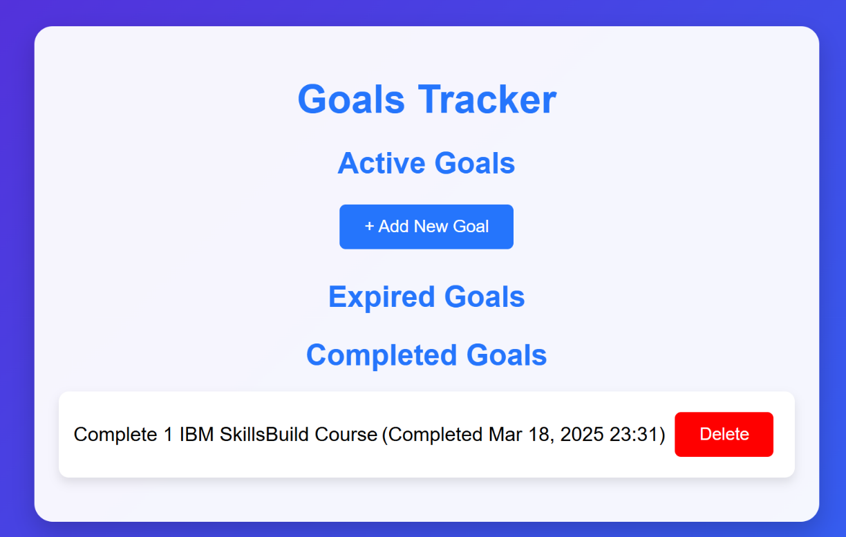
- Deleting a Goal:
  - The user can select a goal from any state (Active, Expired or Completed) to delete.
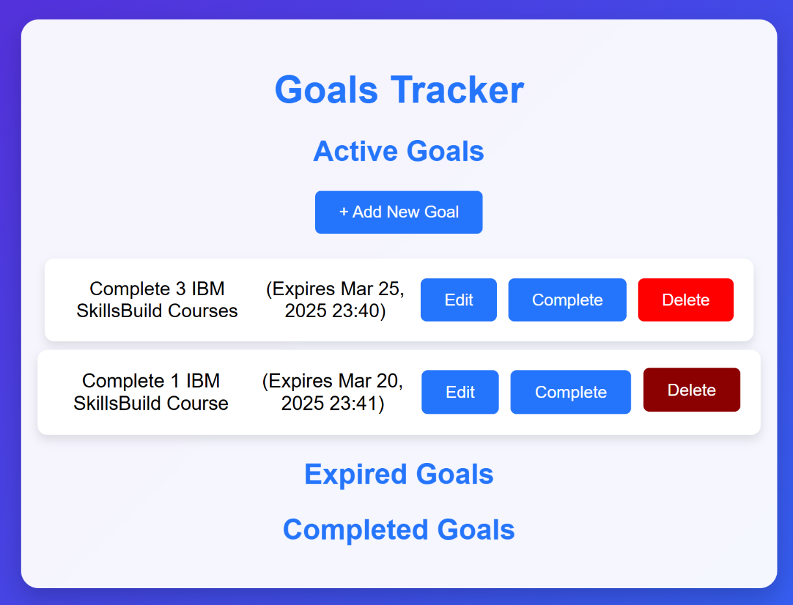
  - The user can click the delete button next to the goal they have chosen to delete at which point the goal will be removed from the tracker.
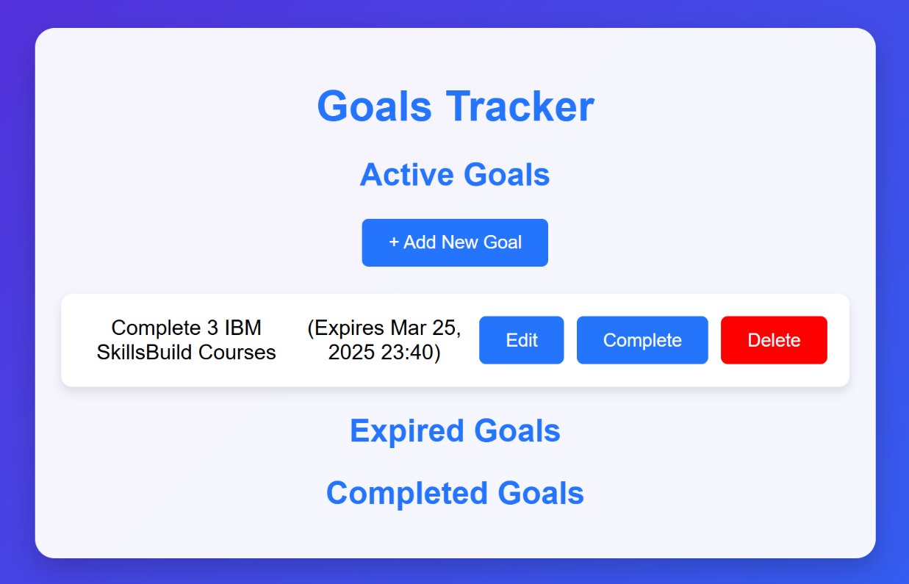
- Goal Expiration:
  - If the user hasn’t completed an Active goal during the goal duration that they have set for it, then the goal will be moved from the Active Goals list to the Expired Goals list.
    - The goal in its active state:
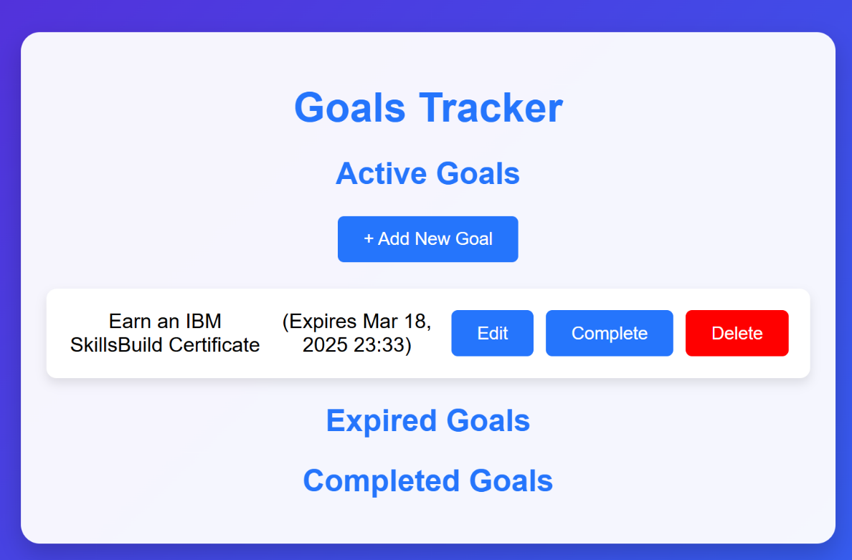
    - The goal after it has expired in the Expired Goals list with date and time of its expiration listed:
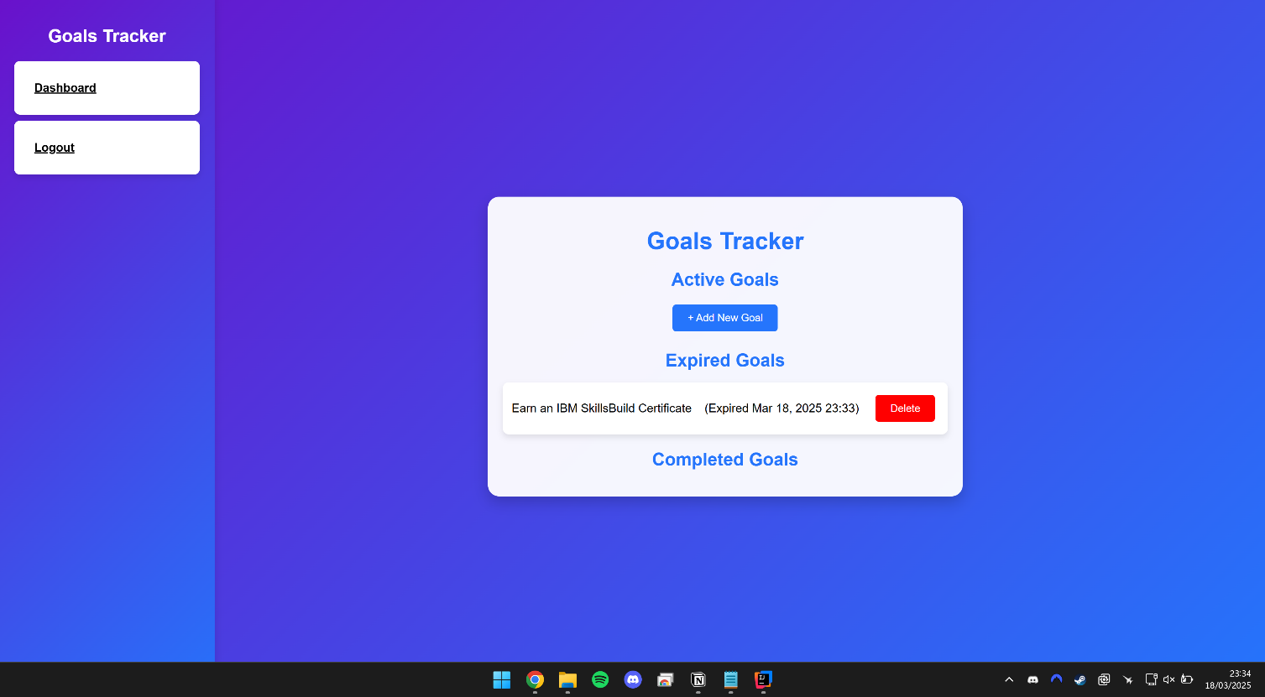
End of User Manual

